SCHOOL

Trial WACE Examination, 2010

Question/Answer Booklet

MATHEMATICS
SOLUTIONS

3A/3B(2)

Section One:

Calculator-free

Student Number: In figures

In words

Your name

Time allowed for this section
Reading time before commencing work: 5 minutes
Working time for paper: 50 minutes

Material required/recommended for this section

To be provided by the supervisor
This Question/Answer booklet
Formula sheet

To be provided by the candidate
Standard items: pens, pencils, pencil sharpener, eraser, correction fluid, ruler, highlighters

Special items: nil

Important note to candidates

No other items may be used in this section of the examination. It is your responsibility to ensure that you do not have any unauthorised notes or other items of a non-personal nature in the examination room. If you have any unauthorised material with you, hand it to the supervisor before reading any further.

Structure of this paper

Section | Number of questions available | Number of questions to be answered | Working time (minutes) | Marks available
Section One:  Calculator-free | 7 | 7 | 50 | 40
Section Two:  Calculator-assumed | 12 | 12 | 100 | 80
 |  |  |  | 120

Instructions to candidates

- The rules for the conduct of Western Australian external examinations are detailed in the Year 12 Information Handbook 2010. Sitting this examination implies that you agree to abide by these rules.

- Write your answers in the spaces provided in this Question/Answer Booklet. Spare pages are included at the end of this booklet. They can be used for planning your responses and/or as additional space if required to continue an answer.
- Planning: If you use the spare pages for planning, indicate this clearly at the top of the page.
- Continuing an answer: If you need to use the space to continue an answer, indicate in the original answer space where the answer is continued, i.e. give the page number. Fill in the number of the question(s) that you are continuing to answer at the top of the page.

- Show all your working clearly. Your working should be in sufficient detail to allow your answers to be checked readily and for marks to be awarded for reasoning. Incorrect answers given without supporting reasoning cannot be allocated any marks. For any question or part question worth more than two marks, valid working or justification is required to receive full marks. If you repeat an answer to any question, ensure that you cancel the answer you do not wish to have marked.

- It is recommended that you do not use pencil except in diagrams.

Section One: Calculator-free (40 Marks)
This section has seven (7) questions. Answer all questions. Write your answers in the space provided.

Working time for this section is 50 minutes.

Question 1 (4 marks)
The graph of 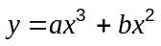 passes through (1, 2), at which point the gradient of the curve is 3.

Find the values of the constants and .
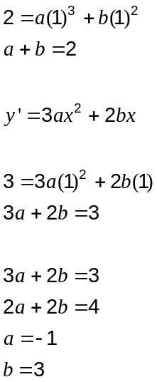

Question 2 (5 marks)
(a) Describe the shaded region in the Venn diagram below using set notation. (1 mark)
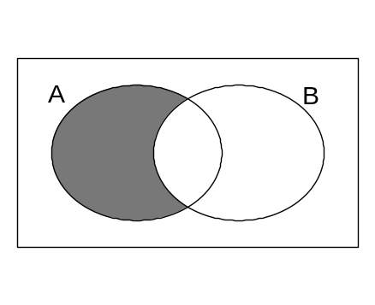
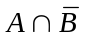

(b) In a group of 11 students, 8 studied Biology, 7 studied Chemistry and 1 studied neither.

(i) How many of these students studied just one of either Biology or Chemistry?
(2 marks)
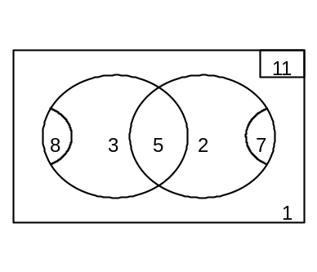3+2 = 5 students

(ii) A team of three students is to be chosen from the eleven for an academic quiz. One student must only study Biology, one must only study Chemistry and the other must study both. How many different teams could be selected? (1 mark)

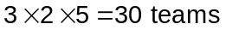

(iii) If three of the students are selected at random from the eleven, what is the probability that they are one of the teams from part (b) (ii)? (1 mark)
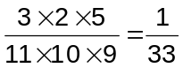

Question 3 (7 marks)
(a) Find 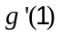 if 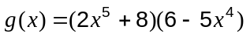. (3 marks)
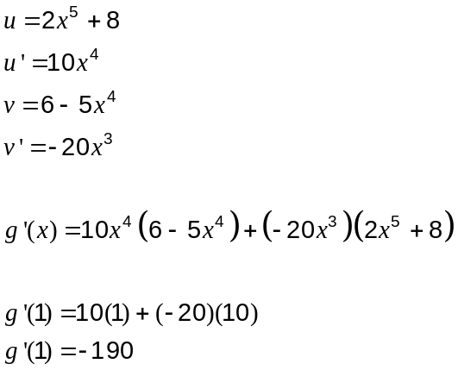

(b) 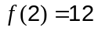 and 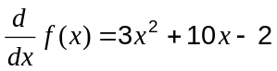.

(i) Find . (2 marks)
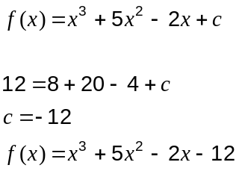

(ii) Determine the average rate of change of from 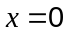 to 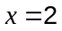. (2 marks)
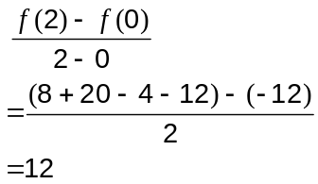
Question 4 (5 marks)
(a) The random variable 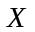 is normally distributed with a mean of 25 and a standard deviation of 4.

(i) Determine 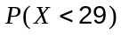. (2 marks)
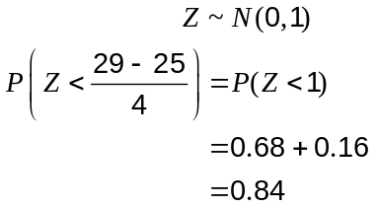

(ii) Given 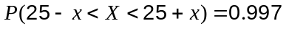, find the value of . (1 mark)
Central area with 99.7% rule.

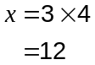

(b) A Road Safety Officer has just received a statistical report on two dangerous highways. Vehicle speeds on both highways were normally distributed. Traffic on Highway A has a mean speed of 95km/h and standard deviation of 15km/h. Traffic on Highway B has a mean speed of 98km/h and standard deviation of 9km/h.

If the officer was concerned about vehicles travelling at excessive speeds, explain which road you would recommend has a speed camera installed. (2 marks)

Highway A.

Mean vehicles speeds are quite close and not excessive, but using 95% rule, fastest 2.5% of traffic exceeds 125km/h on A whilst only 116km/h on B, almost 10km/h slower.

Question 5 (5 marks)
The variables , and are related by the formula 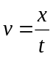.

(a) Find when 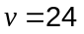 and 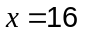. (1 mark)
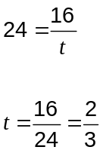

(b) If is constant, describe how the variables and vary with one another. (1 mark)
v and t are inversely proportional.

(c) If 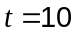 and doubles, how does change? (1 mark)

x also doubles.

(d) If a car takes 6 seconds to travel between two posts 80 metres apart, what is the average speed of the car in kilometres per hour? (2 marks)

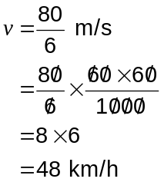

Question 6 (6 marks)
(a) Solve 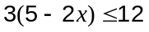. (2 marks)
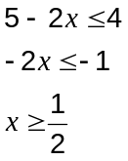

(b) Two functions 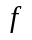 and are given by 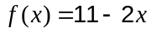 and 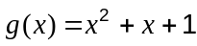. Find the coordinates of the point(s) of intersection of the graphs of and . (4 marks)
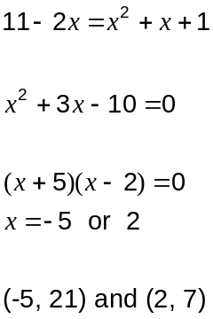

Question 7 (8 marks)
(a) The first and second terms of a geometric sequence are 8 and 12 respectively.

(i) List the next three terms of this sequence. (2 marks)

18, 27, 40.5

(ii) Write down a recursive rule for this sequence. (2 marks)

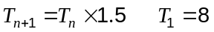

(c) Another sequence for 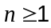 is given by 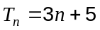.

(i) List the first three terms of this sequence. (1 mark)
8, 11, 14

(ii) Use algebra to prove that the sum of two consecutive terms of this sequence will always be odd. (3 marks)
Let first of consecutive terms be 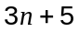.
Then next term will always be 3 more, ie 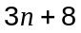.

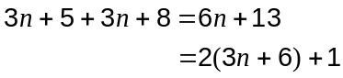

Since 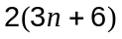 is always even, then 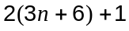 is one greater and so will always be odd.

Additional working space

Question number(s):

Additional working space

Question number(s):

